

**Aictive Filters 설계**



**Topologies of Active Filters**

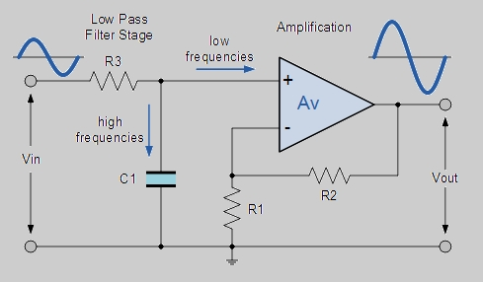 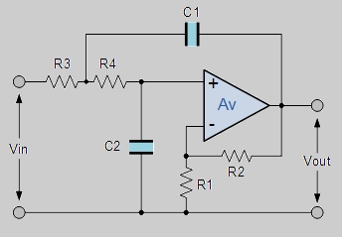

1st order active filter 2nd order active filter

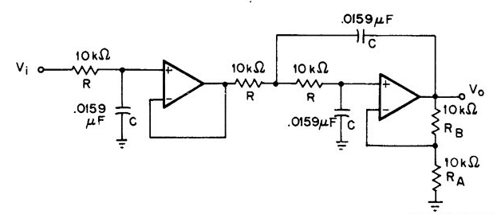

3rd order active filter

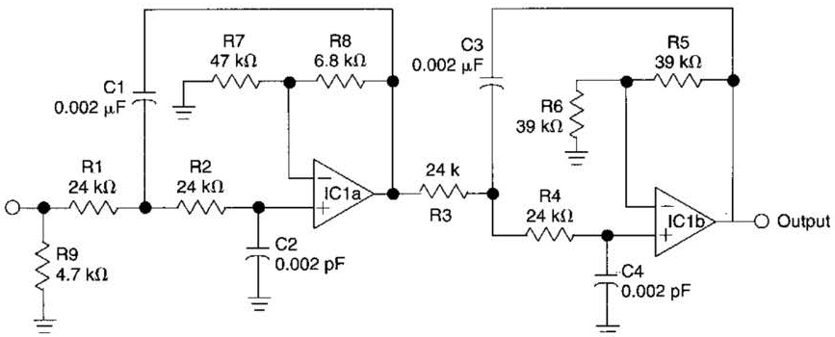

4th order active filter

**Normalized Low Pass Filter Polynomials**

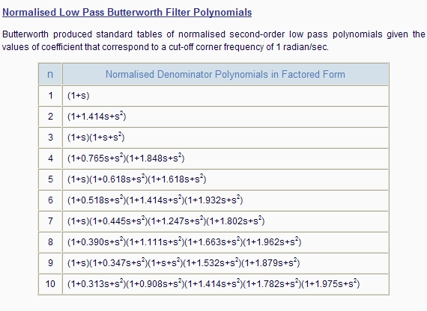

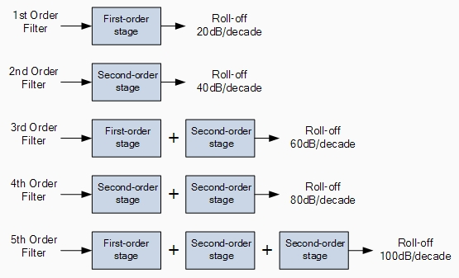

**1st order Low Pass Butterworth Active Filter**

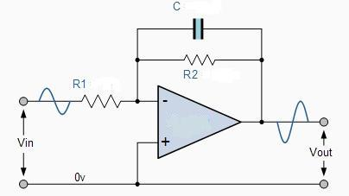



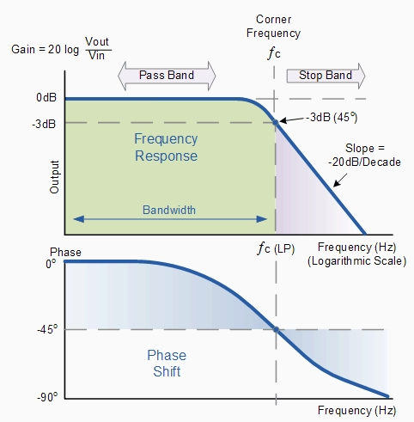

**1st order High Pass Butterworth Active Filter**

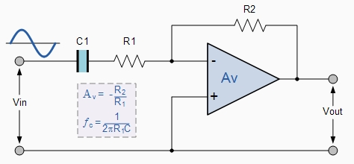

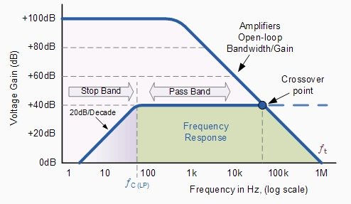

**2nd order Active Filter Topologies**

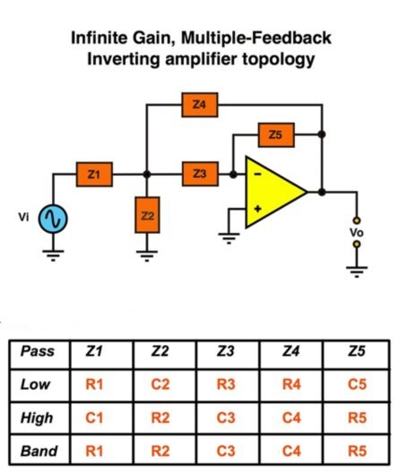

**Transfer Function of IMF Active Filter Topology**



**2nd order Low Pass Active Filter**















**(Design Problem)**

Design a 2nd order Infinite-gain MFB low pass filter.

* Gain in pass band= 2
* Cutoff frequency = 1kHz
* C2= 0.1uF

**2nd order High Pass Active Filter**













**(Design Problem)**

Design a 2nd order Infinite-gain MFB high pass filter.

* Gain in pass band= 2
* Cutoff frequency = 1kHz
* C1= 0.1uF

**(Appendix)**





**2nd order Band Pass Active Filter**















Frequency Responses with respect to Q

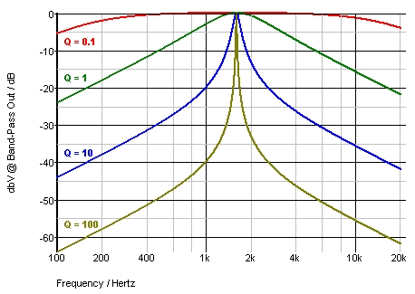

Circuit Topologies of Wide Band Pass Filter

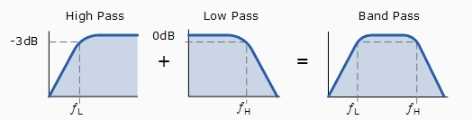

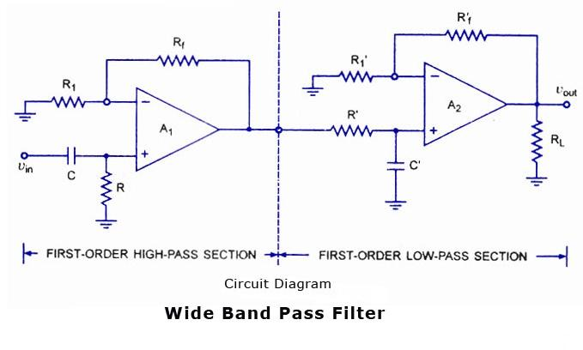

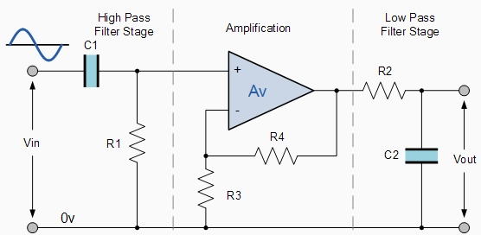

**(Appendix)**





**(Design Problem)**

Design a 2nd order Infinite-gain MFB band pass filter.

* Gain in pass band= 1, Center frequency = 1kHz
* Q=10, C1= 0.1uF

**2nd order Band Stop Active Filter**





Frequency Responses with respect to Q

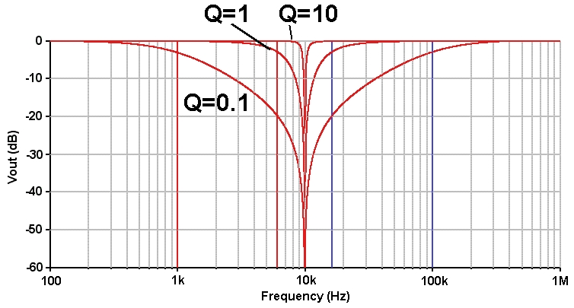

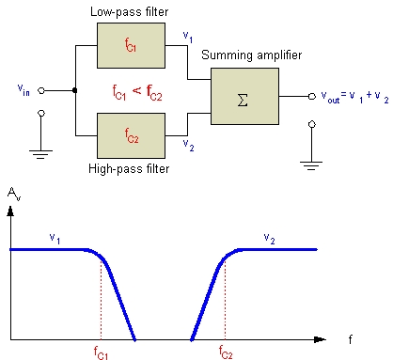

Wide Band Stop Filter

**(Design Problem)**

Design a 2nd order Infinite-gain MFB band stop filter.

* Gain in pass band= 1, Center frequency = 1kHz
* Q=10, C1= 0.1uF